**Day 11- Exception handling Task**

1. What are the four access modifiers available in Java and what is their significance in terms of class, method, and variable accessibility?

Public:

Class - If a class declared as public, it can be accessed from any other class.

Method - A public method can be called from any other class.

Variable - A public Variable can be accessed from any other class.

Private:

Class - A private class cannot be accessed from outside the class it is defined in.

Method - A private method cannot be accessed from outside the class it is defined in.

Variable - A private variable cannot be accessed from outside the class it is defined in.

Default:

Class - If no access modifier is specified (default), it is visible only within its package.

Method - A default (package-private) method can be accessed from within the same package.

Variable - A default (package-private) variable can be accessed from within the same package.

**Protected**

Class - A protected class is not commonly used. It restricts access to the class to its package and subclasses.

Method -A protected method can be accessed from within the same package and by subclasses.

Variable -A protected variable can be accessed from within the same package and by subclasses.

1. What is the difference between Exception and error?

Error:

* An error is a subclass of Throwable that tells that something serious problem is existing
* Generally, it has been noticed that most of the occurring errors are abnormal conditions and cannot be resolved by normal conditions.

Errors usually occurs:

1. Error

Indicating a serious but uncatchable error is thrown. This type of error is a subclass of Throwable.

1. Class Format Error

When JVM attempts to read a class file and find that the file is malformed or cannot be interpreted as a class file.

1. **Out of Memory Error**

In case JVM cannot allocate an object as it is out of memory, such error is thrown that says no more memory could be made available by the GC.

1. **Virtual Machine Error**

Indicate that the JVM is broken or has run out of resources, essential for continuing operating.

1. **Assertion Error**

To indicate that an assertion has failed.

Exception:

Exception is an event or object that represents an abnormal or unexpected condition that arises during the execution of a program. When an exceptional condition occurs, an exception object is created, and the normal flow of the program is disrupted.

1. Checked Exceptions (Compile-time exceptions):

These are exceptions that the Java compiler forces you to either catch or declare in the method using the throws keyword.

1) IO Exception,

2) FileNotFoundException,

3) SQL Exception.

1. Unchecked Exceptions (Runtime exceptions):

These are exceptions that occur at runtime and are not explicitly checked by the compiler.

1. Arithmetic exception:

Occurs when an arithmetic operation encounters an exceptional condition, such as division by zero.

1. **Null Pointer Exception**: Thrown when trying to access or invoke methods on an object reference that is null.
2. Array index out of bound exception**:**

Occurs when trying to access an array element with an index that is outside the bounds of the array.

1. Illegal argument exception:

Thrown to indicate that a method has been passed an illegal or inappropriate argument.

1. Number format exception**:**

Occurs when attempting to convert a string to a numeric format, but the string does not have the appropriate format.

We can handle the Exception using bellow key words try, catch, and finally blocks.

Try - The code which is expected to through exception will reside try block

Catch **-** We can handle the exception to give some instructions in this Catch block

Finally **-** Finally block contains set of code that’s execute the code even exception is not occurs

Throw- Throw is a key word used to declare exception in the method level,

we can throw one exception at a time

Throws - Throws keyword is used to declare exception in the with the method signature,

We can declare multiple exceptions using throws keyword that can be thrown by the method

1. Arithmetic Exception

* occurs when an arithmetic operation encounters an exceptional condition, such as division by zero.

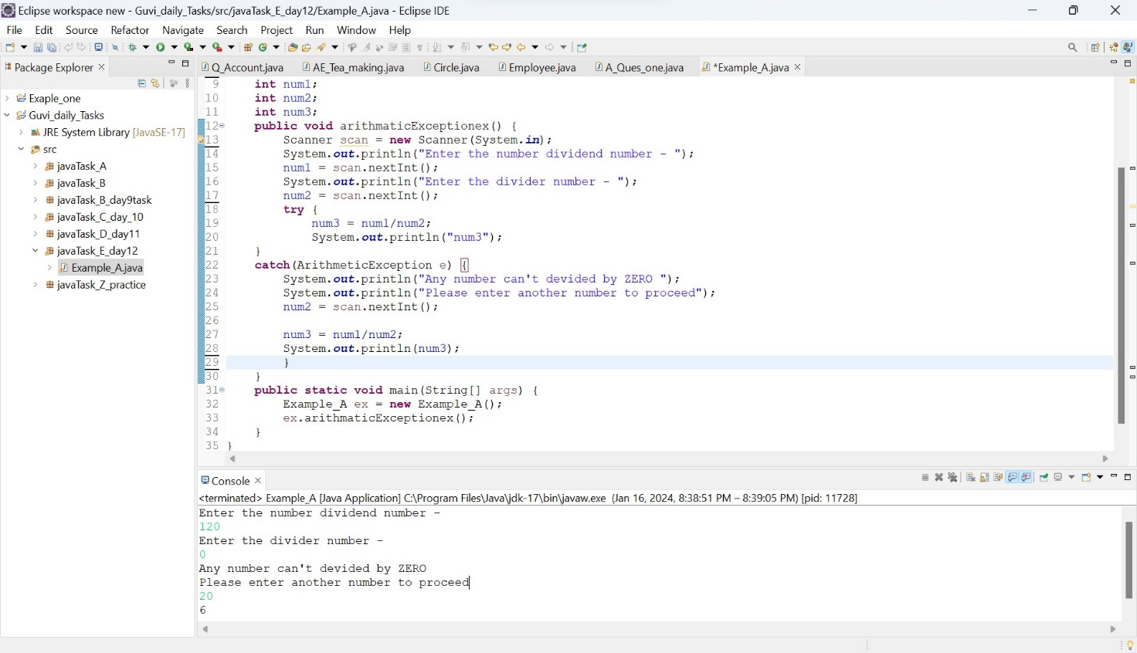

1. Array Index bound Of Exception

* occurs when trying to access an array element with an index that is outside the bounds of the array.

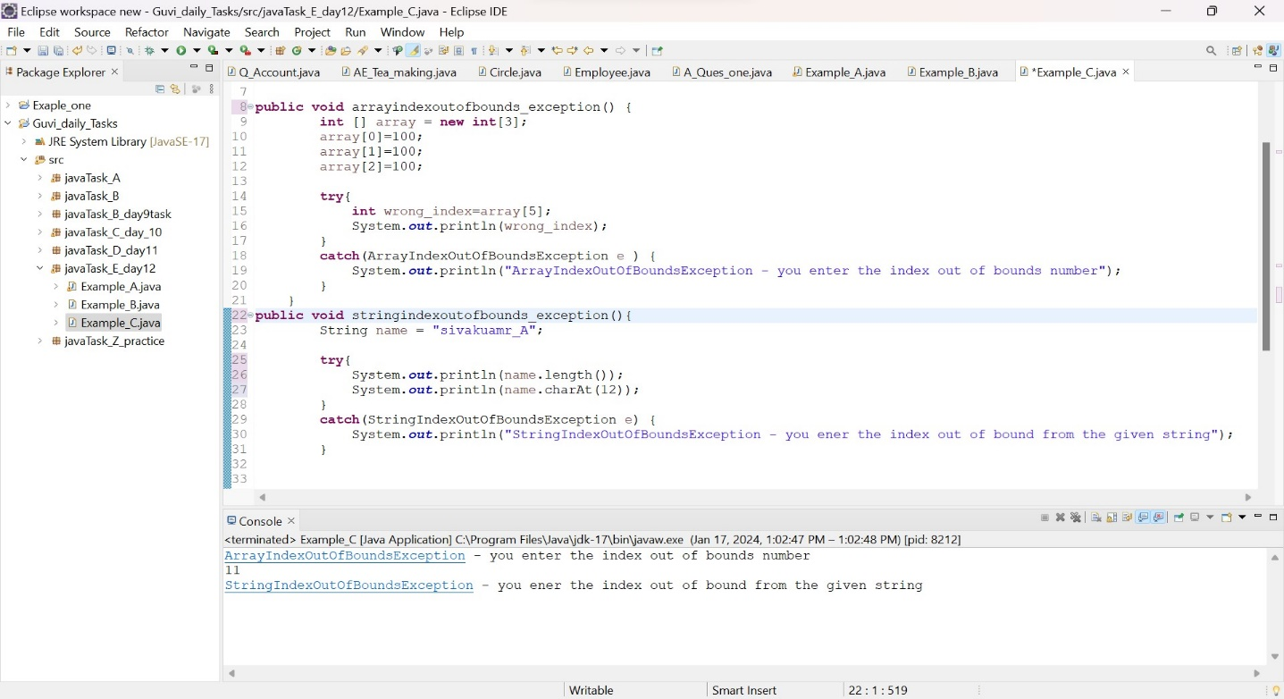

1. You are building a login system for a website using Java. If the user enters an incorrect password, you want to display a message informing them of the error

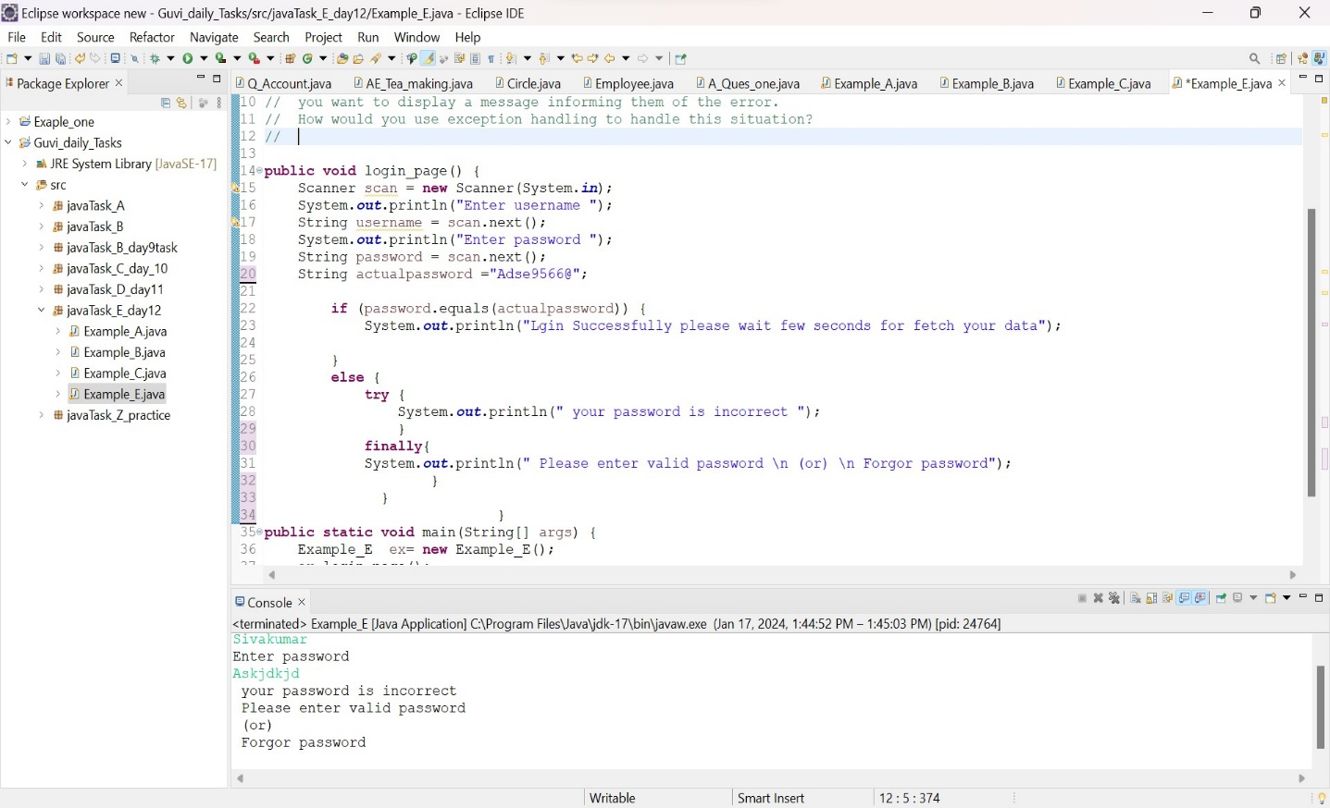

1. File not found Exception

